**Putu Bagus Willie Yudha Maheswara**

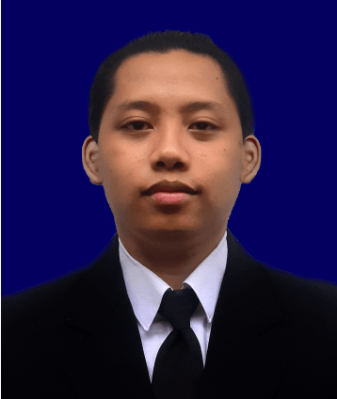

EDUCATION

**COLLEGE**

**2016 – 2020**

**PRIMARY SCHOOL**

**2004 – 2010**

**SD KRISTEN HARAPAN**

**SMP KRISTEN HARAPAN**

**JUNIOR HIGH**

**2010 – 2013**

**HIGH SCHOOL**

**2013 – 2016**

**My Profile**

**SMA NEGERI 6 DENPASAR**

**ITB STIKOM BALI**

**Name**

Putu Bagus Willie Yudha Maheswara

**Place and Date Of Birth**

Denpasar, 19 Juni 1998

**Gender**

Laki – Laki

**Religion**

Hindu

**Nationality**

Indonesia

**Address**

Jl. Tukad Citarum F1 No 81, Denpasar

**Phone Number**

082144019880

**Email**

putubaguswillie@gmail.com

SKILL

Can use the Php, Html, Css, Javascript, Boostrap and Laravel Framework.

HOBBY

* Playing Game
* Listening To Music
* Watching Movies